**BLINKIN DATA ANALYSIS**

**--NULL VALUES FIND**

**SELECT COUNT(*) FROM BLINK**

**WHERE Item_Weight IS NULL**

**--NULL VALUES UPDATE**

**UPDATE BLINK**

**SET Item_Weight = 12.85**

**WHERE Item_Weight IS NULL**

**--📊 Project 1: Sales Performance Dashboard**

**--🎯 Objective: Understand overall sales across outlets and item types.**

**--🔹 KPIs:**

**--1️ Total Sales**

**SELECT SUM(SALES) AS TOTAL_SALES**

**FROM BLINK**

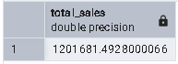

**--2️ Average Sales per Product**

**SELECT AVG(SALES) AS TOTAL_SALES**

**FROM BLINK**

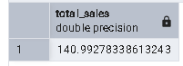

**--4️ Top 5 Selling Item Types**

**SELECT ITEM_TYPE, SUM(SALES) AS TOP_ITEM**

**FROM BLINK**

**GROUP BY ITEM_TYPE**

**ORDER BY TOP_ITEM DESC**

**LIMIT 5**

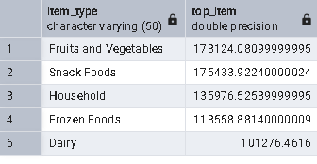

**--5️ Sales by Outlet Type**

**SELECT OUTLET_TYPE, SUM(SALES) AS TOTAL**

**FROM BLINK**

**GROUP BY OUTLET_TYPE**

**ORDER BY TOTAL DESC**

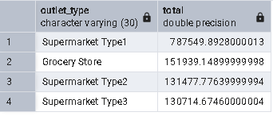

**--6️ Sales by Outlet SIZE**

**SELECT OUTLET_SIZE, SUM(SALES) AS TOTAL_SALES**

**FROM BLINK**

**GROUP BY OUTLET_SIZE**

**ORDER BY TOTAL_SALES DESC**

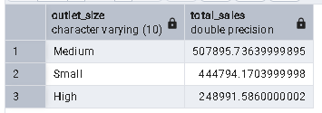

**--7️ Sales by Location Tier**

**SELECT OUTLET_LOCATION_TYPE, SUM(SALES) AS SALES**

**FROM BLINK**

**GROUP BY OUTLET_LOCATION_TYPE**

**ORDER BY SALES DESC**

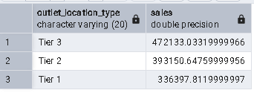

**--8️ Year-wise Sales Trend**

**SELECT Outlet_Establishment_Year, SUM(SALES) AS SALES**

**FROM BLINK**

**GROUP BY Outlet_Establishment_Year**

**ORDER BY SALES DESC**

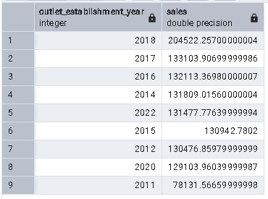

**--9️ Average Rating**

**SELECT AVG(RATING) AS AVG_RATING**

**FROM BLINK**

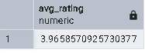

**--10 Item Visibility vs Sales**

**SELECT ITEM_VISIBILITY, SUM(SALES) SALES**

**FROM BLINK**

**GROUP BY ITEM_VISIBILITY,SALES**

**ORDER BY SALES DESC**

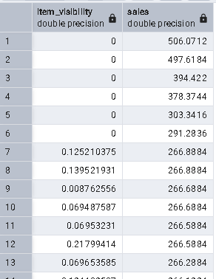

**---**

**--📦 Project 2: Product & Category Insights Dashboard**

**--🎯 Objective: Analyze product performance, customer choices, and category behavior.**

**--2 Sales by Item Type (Category)**

**SELECT ITEM_TYPE, SUM(SALES) AS SALES**

**FROM BLINK**

**GROUP BY ITEM_TYPE**

**ORDER BY SALES DESC**

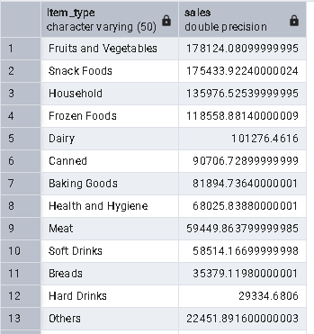

**--3️ Average Sales by Item Weight**

**SELECT ITEM_WEIGHT, AVG(SALES) AS AVG_SALES**

**FROM BLINK**

**GROUP BY ITEM_WEIGHT**

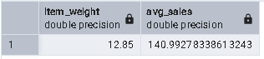

**--4️ Top 5 ITEM**

**SELECT ITEM_TYPE, SUM(SALES)AS SALES**

**FROM BLINK**

**GROUP BY ITEM_TYPE**

**ORDER BY SALES DESC**

**LIMIT 5**

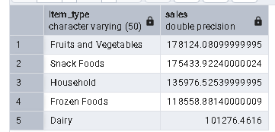

**--7️ Rating-wise Sales Comparison**

**SELECT RATING, SUM(SALES) AS TOTAL**

**FROM BLINK**

**GROUP BY RATING**

**ORDER BY TOTAL DESC**

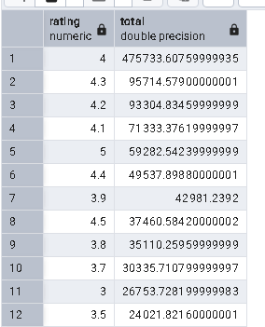

**--8️ Outlet Type vs Item Type Sales**

**SELECT OUTLET_TYPE,ITEM_TYPE, SUM(SALES) AS SALES**

**FROM BLINK**

**GROUP BY OUTLET_TYPE,ITEM_TYPE**

**ORDER BY SALES DESC**

